Composition: Electronic Media II
025:251
Spring 2014
Bouncing Decca-tree Recordings

This handout will take you, step-by-step, how to bounce your anechoic chamber recordings from Tuesday 1/28.

1. Create a new Pro Tools session, naming it “(your name) Anechoic Recordings.”

2. Create three mono audio tracks. (Track > New)

3. Name the top track Mono L, the second track Mono R, the third track Mono C (left, right, center; per the Decca Tree)

3. For the first track, set the output to analog 1; the second to analog 2; and the third to analog 1-2. The edit window track information should look like this:
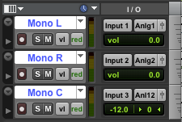

4. Now, go to the folder on the desktop “anechoic recordings 1 28 sorted” and open your audio folder.

5. Sort by “date modified” and drag in one take of a particular microphone. The take number is signified by the number before .aif. The screenshot below signifies the Rodes arrangement, take 26:

6. Using the above screenshot as a model, click and drag RO_L_26.aif to the top track in your Pro Tools Session, RO_R_26.aif into the second track, and RO_C_25.aif in the bottom track:
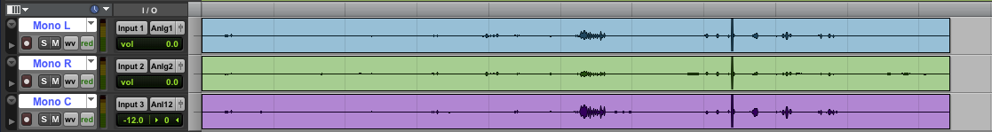

7. Using your ears, balance the C track against the L and R tracks. This can be accomplished using automated volume, as seen below (notice that the automation line on track 3 is lowered significantly; the edit window info shows -20 dB):
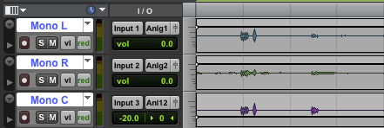

8. When the balance between C and L/R is to your liking, select the entire take and bounce it to disk.
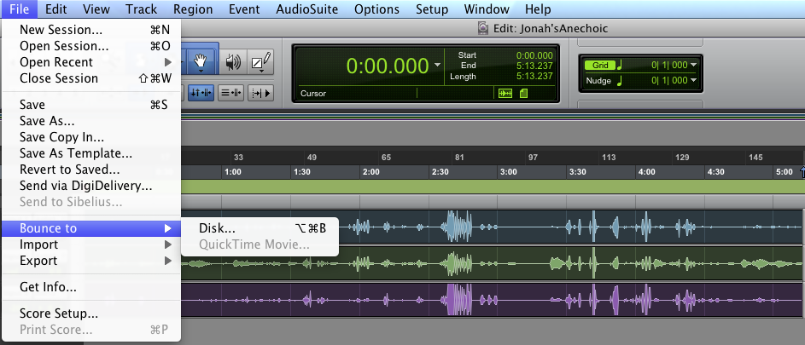
9. Make sure the settings are set to this:
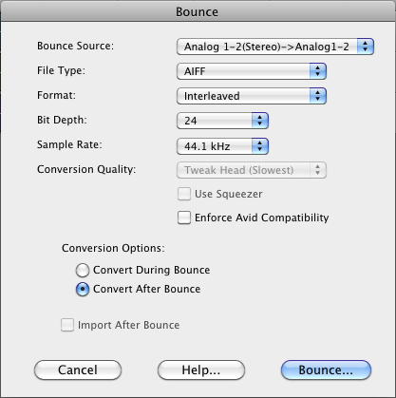

10. The procedure laid out in steps 6 through 9 can be repeated for additional takes. Furthermore, steps 7 and 8 in particular can be repeated to produce a variety of mixes from one take.

