Composition: Electronic Media II
025:251
Spring 2014
Max Icons

1. This handout addresses iconic objects that you may use regularly. While all of these objects can be found in the Object Explorer Window, I will cover the manual entry to maximize your workflow. The convention used in this handout, “[object name]”, is shorthand for “create an object box and type the object’s name.”

2. [slider] outputs values at a range designated by the user in the inspector or by message boxes. You can also check the box next to “Float Output” if you want to float the output.
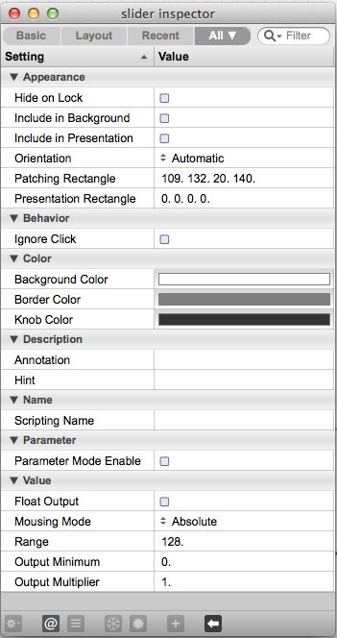

a. You will likely want a float or integer box to monitor the output of the slider. Remember, if the slider is outputting a float value a number box will only interpret the number to the left of the decimal (that is, it won’t round):

3. [dial] functions equivalently to [slider], but gives the user a dial to interface with:

4. [gain~] scales signal exponentially, via a slider. Below, I have a sine tone ([cycle~] singing A440) patched to [gain~], which is then patched to [meter~], which will give a visual representation of the signal strength. This is simply an alternate method to using [*~] as been discussed previously. By now, I hope you are making a connection… anytime tilde is used in naming an object, we are talking about __________________(?):
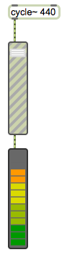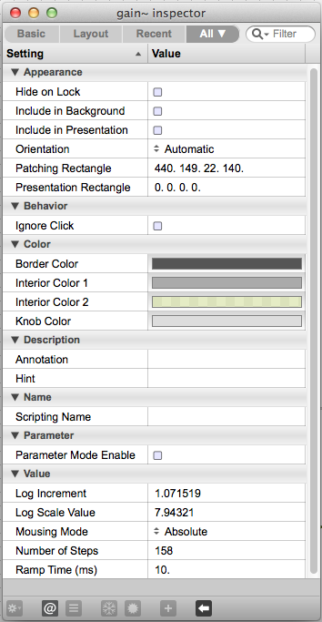

5. You can click and drag the corners of the slider to adjust their appearance (if this will not work for you, go into inspector and set “orientation” to automatic per the screenshot above):
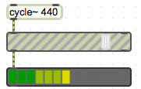

6. And for the traditionalist in you, [levelmeter~] gives you this icon. I left [meter~] for comparison’s sake:
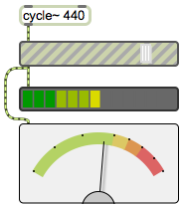

7. Other icons to be aware of, but not necessarily needed: 1. [ezdac~], 2. [ezadc~], and 3. [kslider]:
