Composition: Electronic Media II
025:251
Spring 2014
Max 6: Inspector

1. The Max Inspector allows the user to set values for object-specific parameters in order to best control that object’s behavior. There are three ways to get to the inspector:
a. Control click the object:
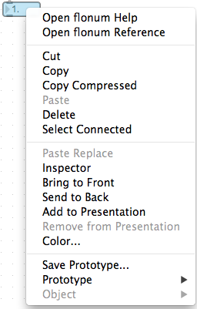
b. Select the object and go to Object > Inspector
c. Select the object and type command I.

2. Each object will have different parameters. For example [flonum] and [number] allow you to set minimum and maximum values, currently set to none:
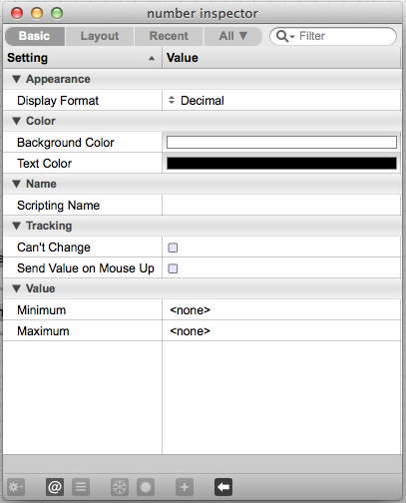

You will find in Max that the idiom “there is more than one way to skin a cat” holds true. For example I can set the minimum and maximum in the inspector to 8 and 10, but I could also send messages “min x” and “max y” into the inlet of [number] to set those values. Furthermore, setting the values in the inspector is not a permanent action; subsequent max or min messages will override the initial values. The inspector is most commonly used for appearance such as setting font, font size and color, or setting the background color.

