Composition: Electronic Media II
025:251
Spring 2014
Menu Items in Max 6

1. This handout addresses the menu bar in Max 6, privileging items you will use more regularly.

2. The “Max” menu item provides you with this submenu bar:
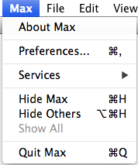

The “Preferences…” submenu item should not be explored or altered. If the patcher behaves unusually, it may be because someone has altered something in preferences. Contact Dan or Will if you suspect preferences have been changed.

3. The “File” and “Edit” menu items provide typical submenu items:
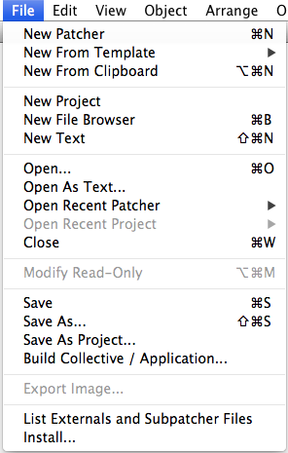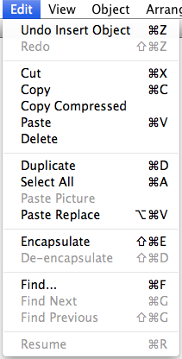

a. File:
i. As in other applications, command N will create a new document; command O will prompt an open dialogue; command W will close the current document; and command S will save your file.
ii. Make a mental note on “Build Collective / Application…” This action will create a “.mxf” file which creates an interfacing version of your patch that no one can edit. That is, a user can interface with it, but cannot edit it. Users can run a .mxf file with either Max 6 or MaxRuntime, a free download hosted on the cycling 74 website. When you have a patch you are ready to share with your performer or the world at larg, ask Dan or Will to walk you through the steps of building a collective.
b. Edit: As in other applications, command Z undoes; command X cuts selected objects; command C copies; command V pastes; command A selects all; and command F prompts the find dialogue, which can be useful if your patch has gotten difficult to manage and have forgotten where you placed a particular object.

4. The “View” menu item contains both typical and Max specific submenu items:
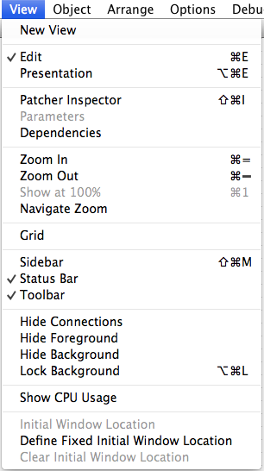

Most of your work will be done in the “Edit” view. You will use “Presentation” mode when you are creating an interface for a user to interact with. Only the objects “added to Presentation” will appear in that view. Command = and command – will zoom in and out, respectively. “Show CPU Usage” monitors how intensive your patch is. The Status Bar and Toolbar appear at the bottom of the screen:

The message “dac~: Audio output and on/off” appears in the Status Bar because I had selected the [dac~] before taking the above screenshot. Directly beneath the Status Bar is the Toolbar, which will be discussed later.

5. The “Object” menu item drops down with this submenu:
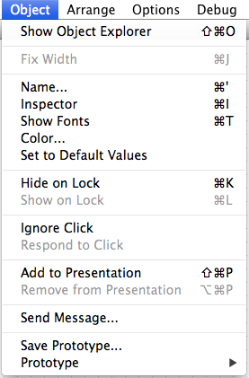

Of this submenu, the most useful are the “Inspector” and “Add to Presentation.” The Inspector allows you to modify object-specific parameters while Add to Presentation will add the selected object to the Presentation view.

6. The “Arrange” menu drops down with this submenu:
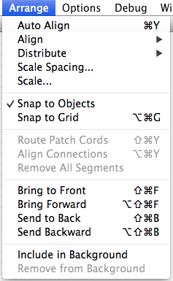

The most used action in this submenu will be “Auto Align” for tidying-up your patch. Consider the following skewed objects:
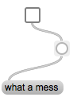

After selecting the above objects, clicking Auto Align results in a vertical alignment:
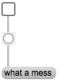

A different scenario:

After selecting the above objects, clicking Auto Align results in a horizontal alignment:

If your goal is a tidy, clean looking patch, you will want to remember command Y as the shortcut key for Auto Align.

7. “Route Patch Cords” under Arrange (shift command Y) can be helpful as well. Consider this tangled web:
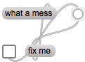

Select the patch cords by clicking on each while holding down shift. Once all are selected, type shift command Y:
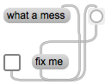

8. “Options” gives you this submenu:
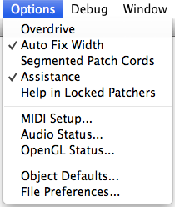

You will not need to use this menu very often. Based on your preference, you may want to check or de-check “Segmented Patch Cords.” With it selected, anytime you click when patching between one object and another, a segment will be created in the patch cord:
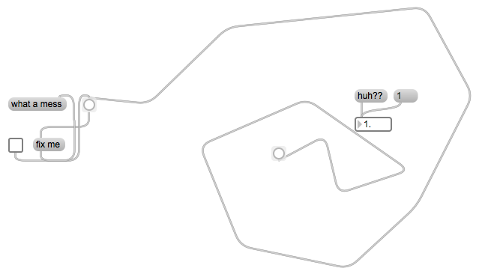
De-selected:

9. You will rarely if ever use the “Debug” menu item.

10. Window provides some useful information:
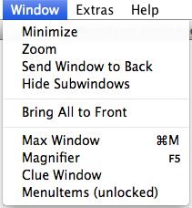

It tells me that my patcher “MenuItems” is unlocked and can therefore be edited. Also, the Max window is very helpful. By clicking on that, the Max window will open and will list everything sent to the [print] object or any errors. In the screenshots included in item 8, above, a message “huh??” is connected to a float object. Because float objects can only understand numerical values, the error will be listed in the Max window:
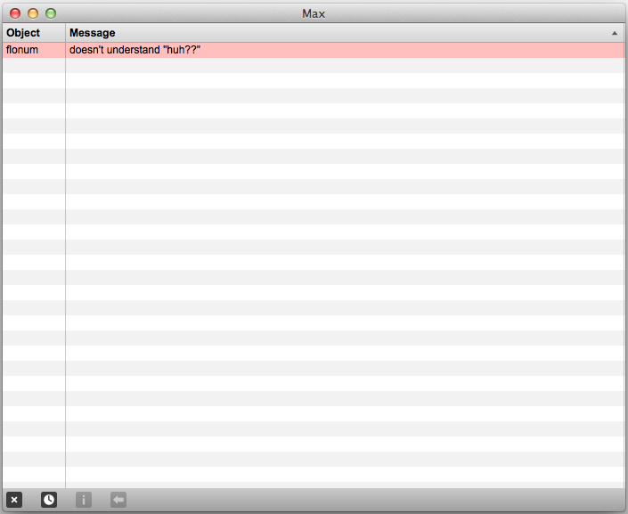

Click the error message and then click on the at the bottom, and the problematic object will be highlighted. Clicking on the x in the lower left hand corner will clear out the window. The clock will arrange the messages chronologically.

11. You will rarely if ever use “Extras.”

12. “Help” is one of the strengths of Max. After selecting an object you need help about, click on Help and then “Open [object] help.” A window like this will open:
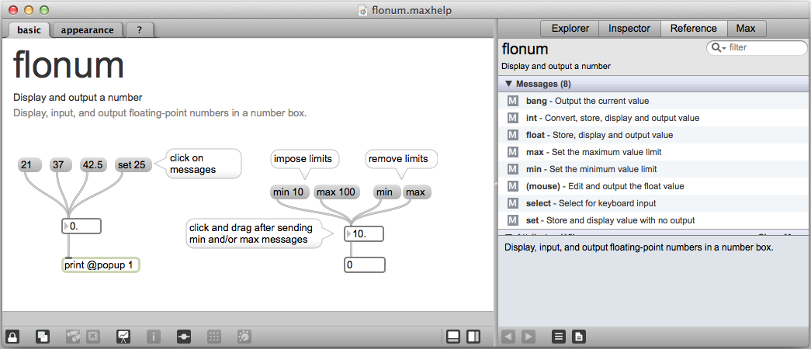

This will help you better understand the behavior of objects you are unsure about.

You can also access the help window by control clicking on the object, and then selecting the help option:
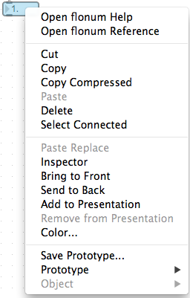

I cannot stress enough how powerful the help files are for a student learning Max.

