Composition: Electronic Media II
MUS:4251
Spring 2015
Anechoic Chamber

- In this handout I will introduce the anechoic chamber, which will include some discussion of how these chambers are able to absorb sound.
- An anechoic chamber is a non-reflective, echo-free room. It is heavily insulated to prevent unwanted noise outside of the room from entering.
  - When a sound is produced inside the chamber, most of the sound is absorbed through walls with triangular-shaped wedges. A very small amount of the sound is reflected.
  - The human ear can usually perceive sounds above 0 dBA. In most anechoic chambers the noise levels will vary from 10 to 20 dB. One of the quietest anechoic chambers in the world has noise levels at -9.4 dB, well below the threshold of hearing. For a person walking into such a room, it would seem like the room is devoid of sound.
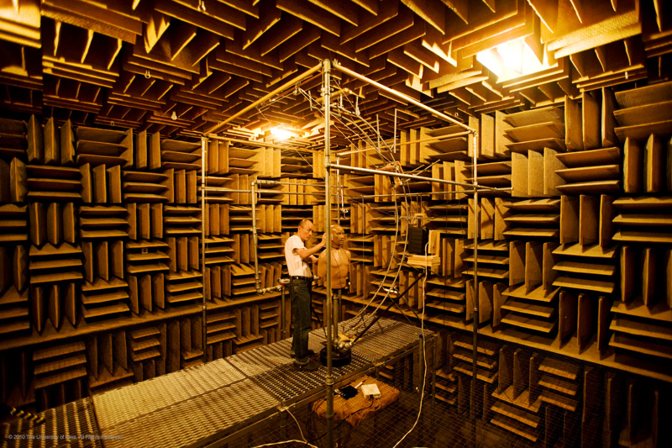
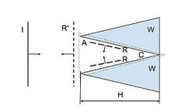
- The anechoic chamber at the University of Iowa is encased in a 30-ft cube of concrete in the basement of the Wendell Johnson Speech and Hearing Clinic. The walls have fiberglass wedges that are attached to the walls with wire screen. Each wedge is 3’10” in length. They absorb the sound when it travels toward the wall. The fiberglass wedges are found on all walls, including the floor and the ceiling. When you go inside, you’ll be walking on a metal catwalk above the floor. The anechoic chamber at this university can absorb frequencies down to 60 Hz. The reason for this limitation is because of how the fiberglass wedges are configured inside the room.

The measurement dBA is used here to express noise levels, the relative loudness of a sound as perceived by the human ear. 25 dBA, as an example, would be a measurement for the loudness of a person whispering in a room. The measurement dB, although it can be expressed as a measurement of sound pressure, is more generic as a means of expressing a relationship between two values for something physical, either power or intensity. dB can also be used to express voltage, radar, radio power, energy, and field strength.

