MUS:4251 COMPOSITION: ELECTRONIC MEDIA II
Spring 2015
Compression

- In this handout we will begin our discussion on compressors and limiters in electronic music. We will introduce various terms associated with compressors and limiters and then apply these terms to situations involving or requiring them. Compressors and limiters, as we’ll find, are often paired together because they are both dynamic processors. However, there are subtle differences between these terms. Other specific processors related to compression such as de-essers, expanders, and multi-band compressors will be explored at another time.
- Compressor – A compressor is used to bring down the peaks, the loudest levels in a sound file. We want to use compression when managing the energy of a signal, lowering peak levels, or reducing a signal’s dynamic range, the difference between the loudest and softest signals. The energy of a signal, as written above, is referring to the strength of a signal. As our ears are very sensitive, it is ideal that changes in energy levels resulting from compression are smooth and hardly noticeable. For example, in a live performance, if a vocalist or speaker shouts for a period of time, and we want to control the loudest levels of signal that will pass through a microphone, we can use a compressor to control the output of the signal that is traveling from the microphone to the speakers.
- When working with compressors, the following terms should be understood when working with any of the compressors we have on Pro Tools or any algorithmic software, such as Max or Pure Data.
  - Threshold: the threshold (measured in decibels) is the level at which the compressor will be activated. The compressor is activated when the signal goes over the threshold level. For example, if the threshold is set at -20 dB, and at a certain point the volume of a sound file increases to -16 dB, the compressor will turn on and reduce the peak down to a specified level, which is calculated by the compression ratio.
  - Ratio: of particular importance is the ratio for the amount of gain reduction that will occur. The ratio has to do with the amount of signal that will be reduced based on the relationship between the input level and output level of signal. That means for each number of decibels at which the input level of the signal exceeds the threshold, the output level will allow only 1 dB to pass through. For example, if we have set a 2:1 ratio for the compressor, this means that for every two dB the input level exceeds the threshold level, the output signal will only allow 1 dB to pass by the compressor, which will result in the compressor cutting the amount of output signal that exceeds the threshold in half. If we consider the previous example in 3a of a sound file increasing to -16 dB when the threshold is at -20 dB, the total amount of output signal will be reduced by 2 dB.
  - Attack and Release: Another factor we want to consider when using a compressor is the amount of time in which the compressor will be turned on and off. This corresponds to the attack and release times on the compressor. These times are measured in milliseconds. The longer the amount of time, the more gradual the compression will be.
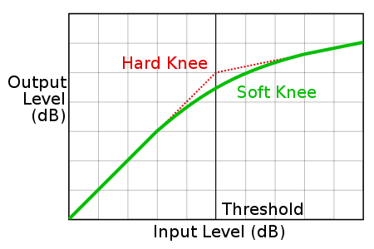
  - Soft and hard knee: Some compressors have what are called soft/hard knees. This involves the gradual increase or decrease of the compression ratio based on the level of the input level. If the input level increases, the compression ratio will increase. The soft knee will increase the compression ratio more slowly than the hard knee. A soft knee might be considered more desirable than a high knee if the compression ratio is particularly high because the effect of a hard knee will be more noticeable.

e
e
  - Makeup gain: this is the amount of output volume increased after compression has been applied to the sound itself.
  - Look-ahead: this function can be used to anticipate when a spike in the signal will occur, but the look-ahead function on a compressor does not anticipate an increase in levels. Instead, the signal is split into two parts, with one side of it being delayed. The signal that is not delayed is used to compress the delayed portion of the signal. By doing so, this can function as an intermediary between slow and fast attack rates.
  - Stereo link – this is used to ensure that compression, when it occurs in one side of the stereo field, will also be applied to the other side. Otherwise, the lack of a stereo link would cause the “phantom center” to be distorted. The stereo field will seem to be oriented heavily to one side of the field.
- Limiter – Another type of dynamic processor, limiters use higher compression ratios. Typically, limiters will use a compression ratio of 20:1 or higher, depending on the needs of the audio engineer. The attack and release times of limiters are also considerably faster than a compressor. The benefit of a limiter is that it can quickly lower a brief segment of sound that exceeds that the threshold.
  - Question: considering now the differences between a compressor and a limiter, which would be more useful to apply to a loud sharp articulation that exceeds a given threshold: a compressor or a limiter?
- Let us discuss several of the different dynamic plug-ins that we have in our studios. Let’s begin with the L1 Ultramaximizer Stereo plugin. This plugin is designed specifically for mastering, digital editing, multimedia, and any other applications that require some form of limiter. To maintain the highest level of resolution of your pieces, make this plugin the last plugin that you use.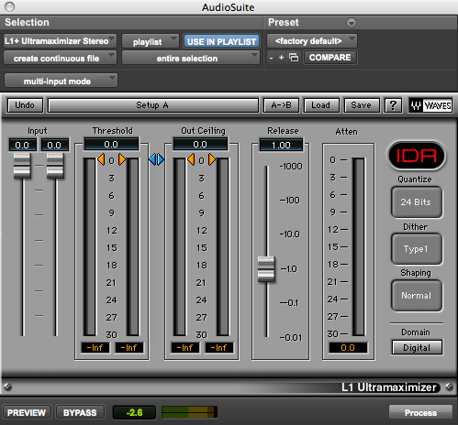
  - This plugin has several different features. The first is the threshold level, which can be adjusted up or down as desired. Any signal that exceeds the threshold level will appear in the Attenuation column on the far right of the plugin. This indicates how much of the signal has been lowered because the input has exceeded the threshold level. The Out Ceiling is the volume limit, which will increase the volume to the specified level of your choice. This is very similar to normalization in that the plugin has a limit up to 0.0 dB. Also note that you can control the amount of signal that is going into the plugin by using the input sliders on the left side of the plugin. Other options to the right side of the menu are for dithering, which includes the bit depth, dither type, and noise shaping.
  - For more specific information regarding the L1 Ultramaximizer, please consult the User Guide for this plugin at the following link: http://www.waves.com/1lib/pdf/plugins/l1-ultramaximizer.pdf
  - Please remember that it is highly recommended that you should only use this plugin after all processing, EQ, sample rate conversion, and dynamic changes, has been done to your entire project to avoid clipping.

