Composition: Electronic Music II
MUS:4251
Spring 2015
MIDI Instruments in Pro Tools

1. To create an instrument track in Pro Tools, do the following.
a. In the Track menu, select New. A window like the one below will appear:
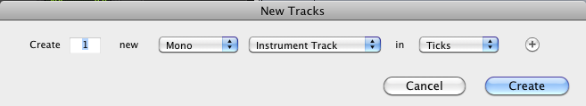
b. Select “Instrument Track” as shown above.
c. The new track will appear in the Edit window, as shown below:
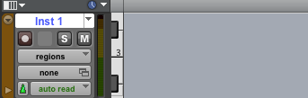

2. Select an instrument as follows.
a. In the View menu, select Edit Window Views>Inserts A-E, as shown below.
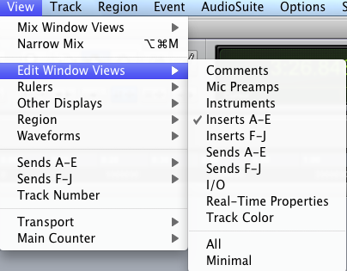

b. The Inserts display is shown in the track window, as seen below.
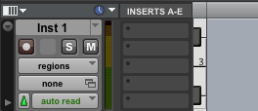

3. Choose an instrument as follows.
a. Click on a blank insert tab to select plug-in>Instrument>Xpand2 (mono), as shown below.
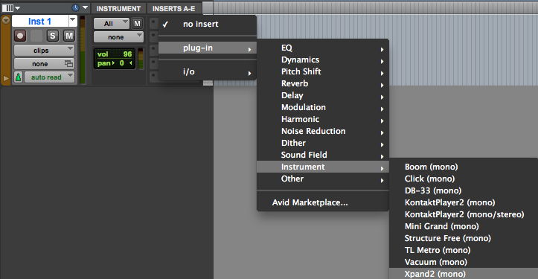

b. Xpand2 (mono) contains a number of instruments that are native to Pro Tools 9 and newer. Using these
instruments ensures compatibility with other computers running Pro Tools. Other categories, like the ones listed in the menu, may not be installed on other computers.
d. After selecting plug-in>Instrument>Xpand2 (mono), a window like the one below will appear.
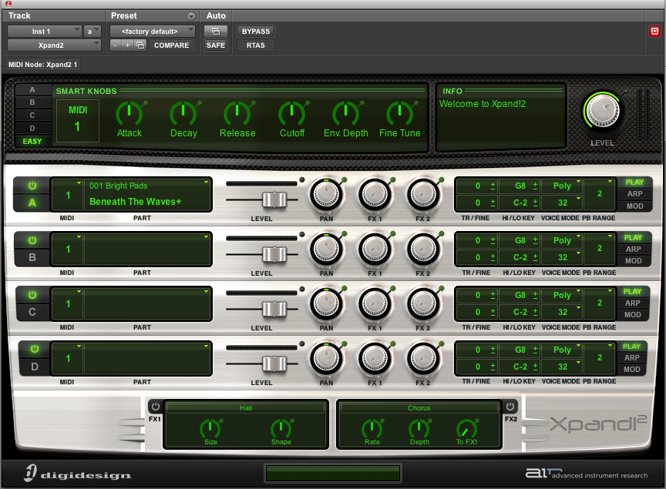

e. Notice the 4 insert windows in the lower left of the module, as shown below.
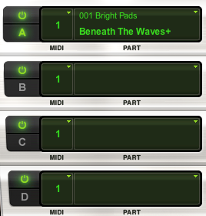

f. Click on Insert A and navigate through the menus to your desired instrument. A flute is shown in the Insert A window, as shown below.

4. We can now begin writing our music
a. In the Instrument track window, change the drop down menu defaulted to clips as seen under item 3a to notes as show below.
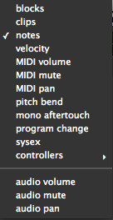

b. Take note of the other options in the drop down menu shown above. As discussed in class, you will want to make use of these parameters, especially velocity (intensity of attack), MIDI volume, MIDI pan, and pitch bend. Choosing one over the other determines what you will be editing in the track. This is analogous to when we worked in audio tracks last semester and could work in the pan domain or the volume domain.
c. Using the pencil tool, highlighted below to the right,
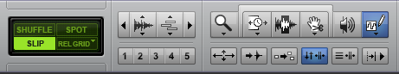
allows you to write notes and have them played back as seen below.

