MUS:4250:0001 COMPOSITION:ELECTRONIC MEDIA I
Fall 2016
Crossfades

- A crossfade is an audio mixing technique of overlapping two clips that are adjacent to one another with fades. A crossfade uses two faders simultaneously on two sources, but in opposite directions: a fade out on the first source and a fade in on the second. The goal of a crossfade is to make a seamless connection between the first and second sources, such that no pops or clicks are distinguishable.
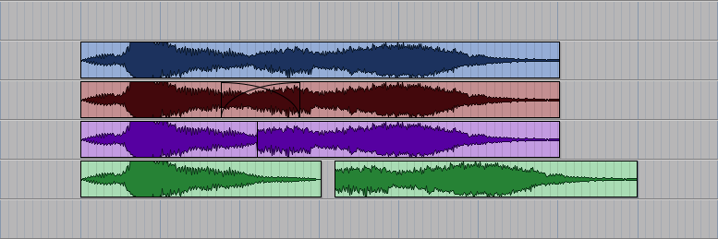
- In Pro Tools, crossfades can be done either on the same track or on two different tracks. If a crossfade is done on the same track, you would highlight two adjacent clips:
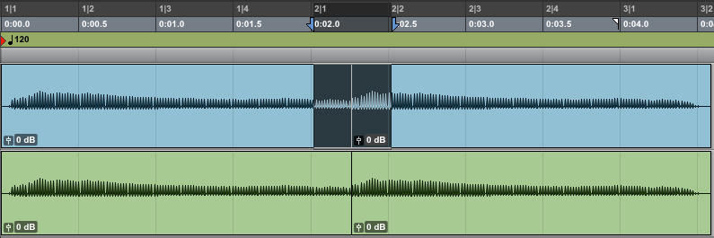

Then, use the fade command (cmnd + f) to bring up the crossfade window.

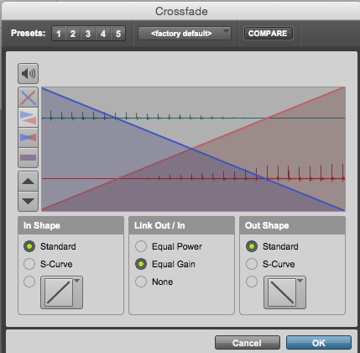
- When you click OK, you will get the following.
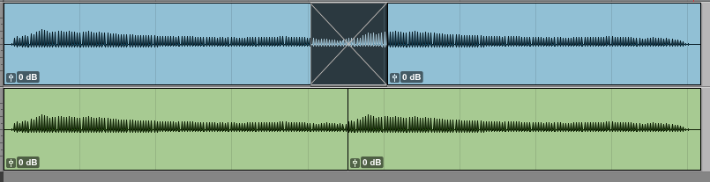
- A crossfade can also occur between two different tracks if you position two clips close to each other, highlight them, and bring up the crossfade window (cmnd + f).
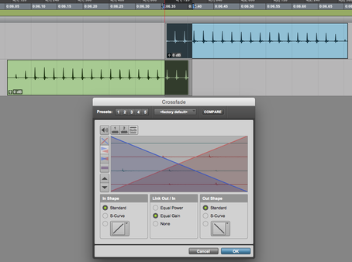
- Notice the result of the crossfade that occurs between these two tracks.
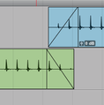
- Please note that fades and crossfades cannot be created if the total duration of a fade or crossfade is less than 4 samples. You will receive a message indicating that there is insufficient audio data to create a sample if that happens.

