MUS:4250 COMPOSITION: ELECTRONIC MEDIA I
Fall 2016
Basic Microphone Theory

1. Much like an eardrum, microphones contain diaphragms that react to fluctuations in air pressure. The motion of the diaphragm is then converted into an electrical waveform. This electrical waveform is an analog (copy) of the original.

2. Generally, a microphone will fall under one of two types: dynamic or condenser. Dynamic microphones require no external power to work. However, condenser microphones contain capacitors, which require electrical power.

3. Dynamic microphones also fall under two general types: moving coil, and ribbon.
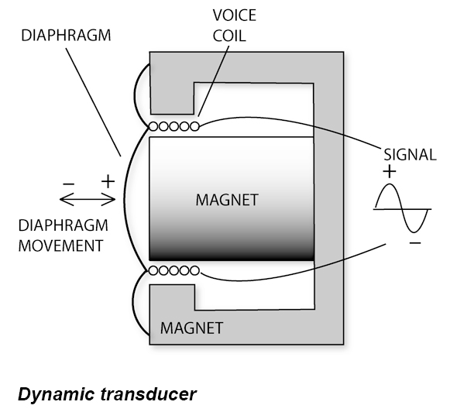
a. Moving coil microphones contain a diaphragm that is attached to a coil of wire. This coil sits inside a magnet, and when the diaphragm moves, the coil moves within the magnetic filed. The motion creates an electric current, which is a proportional representation of the originating waveform.

i. Moving coil microphones are very rugged and can take a beating.
ii. Moving coil microphones can accept high sound-pressure levels (SPL), such as those generated by guitar amps, or kick and snare drums.
iii. Moving coil microphones have very low handling noise, which means the microphone can be handled or moved around without generating too many undesirable noises. This is not the case with other more sensitive microphones.
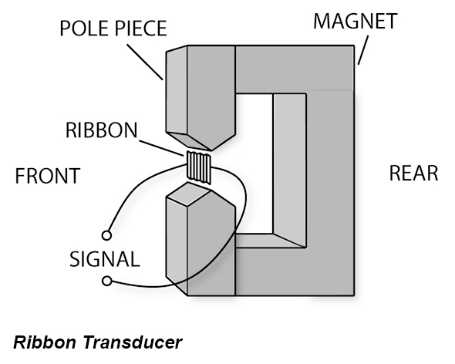
b. Ribbon microphones use a thin piece of metal that is suspended within a magnetic field. The ribbon acts as both the diaphragm and as the transducer (the same job of a moving coil).

i. The ribbon is very sensitive and can be damaged if the microphone is dropped or struck.
ii. Do NOT provide a ribbon microphone with external (phantom) power. This will destroy the ribbon.
iii. Ribbon mics cannot handle as many SPLs as moving coil. However, they are good for recording bright sounds, such as brass, piano, and certain vocal types.

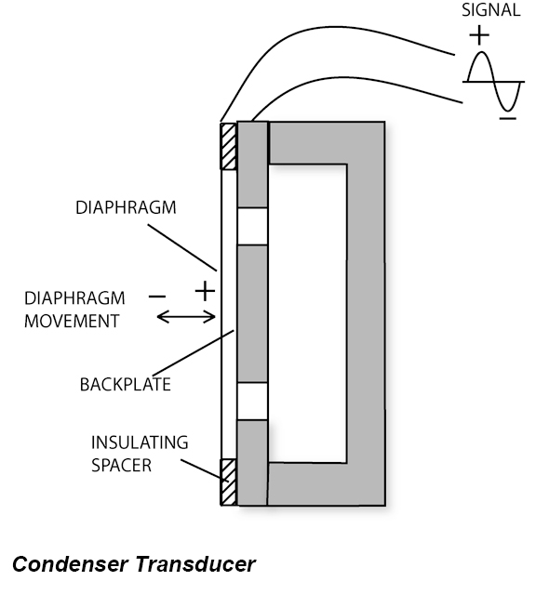
4. Condenser microphones use a capacitor instead of a coil or ribbon. This capacitor requires power in order for the microphone to work. The capacitor in a condenser microphone is in the form of a metal diaphragm and a fixed backplate. Phantom power provides the polarizing voltage instead of a magnet. When the diaphragm vibrates, it is moving closer and further away from the back plate. This action creates the analog of the original waveform.

a. Condenser microphones require external power to work. They draw this power from a variety of different ways.
i. Phantom power can be provided from a mixer or recording device. There is usually a button or switch that turns the phantom power on and off. The amount of power provided is 48 volts.
ii. Some condenser microphones use vacuum tubes, and come with their own proprietary power supplies. This is usually a box the microphone plugs into, and then the box plugs into the mixer or recording device. No phantom power from the mixer or recording device is necessary.
iii. Other condenser microphones draw power from a battery inside the microphone.
b. Some condenser microphones are used with a shock mount. The shock mount is designed to reduce handling noise.
c. Condenser microphones are regarded as the most sensitive of microphones, meaning, they produce the most “true” representation of the original acoustical source. They are generally used to record more nuanced sound sources. They can handle high SPLs and can be used with almost any sound source. They should be handled with care, and never dropped or struck.

5. All microphones have a polar pattern, which is the range of direction that the microphone is sensitive to sound. There are generally three types of polar pattern: unidirectional (cardioid), bidirectional, and omnidirectional.
a. Unidirectional polar patterns are often called cardioid because of the heart shaped pattern of their range. They generally reject sounds coming from the sides and rear.
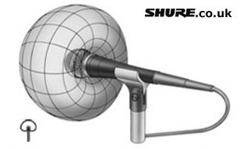
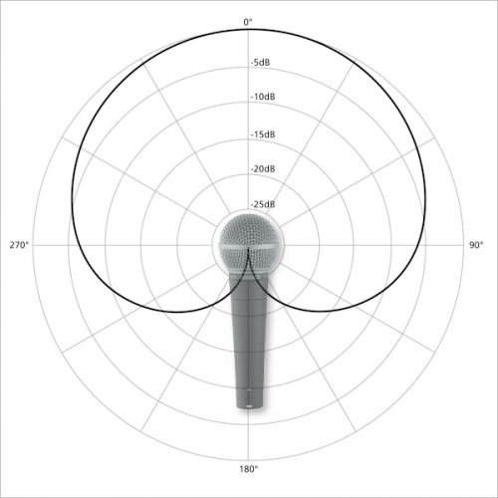
i. Cardioid:

ii. Other cardioid patterns increase the decibel and directional range toward the back of the microphone.

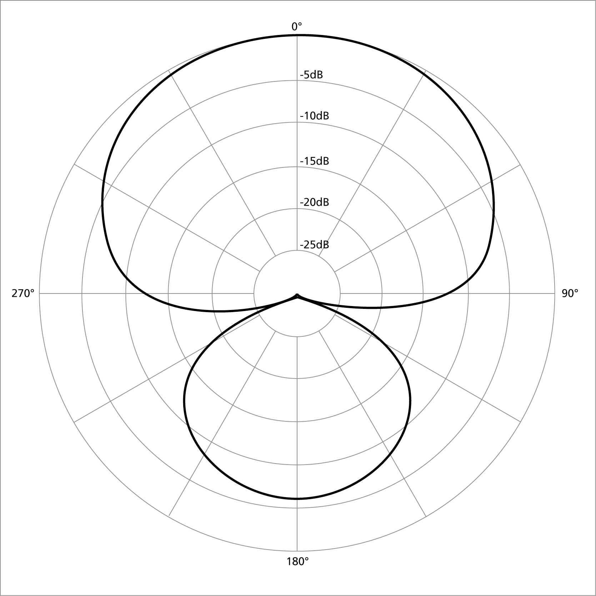
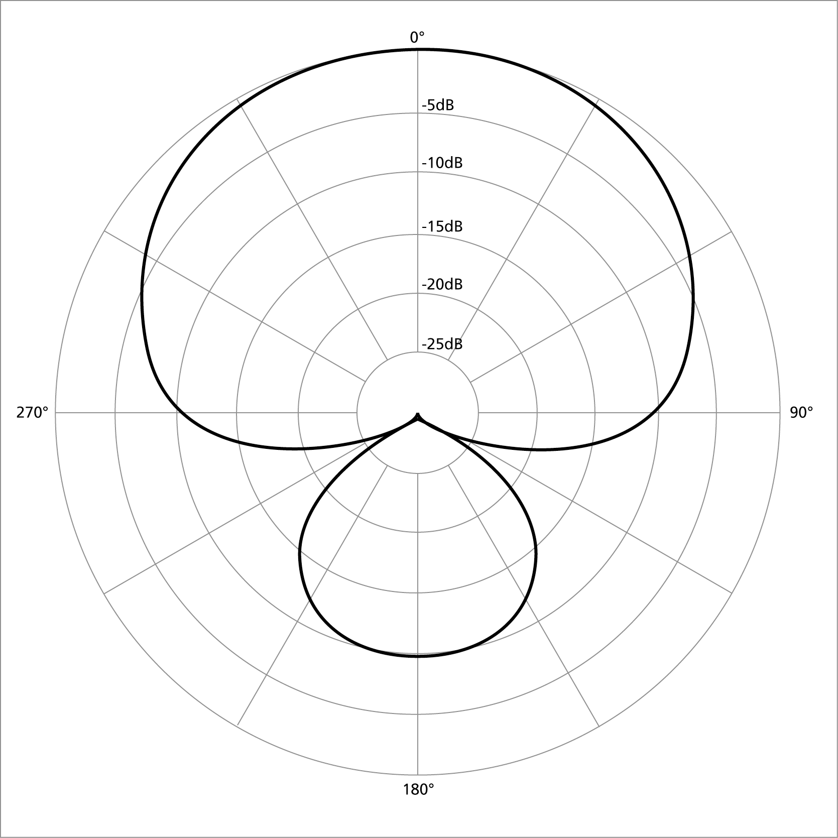
iii. Super Cardioid and Hypercardioid:

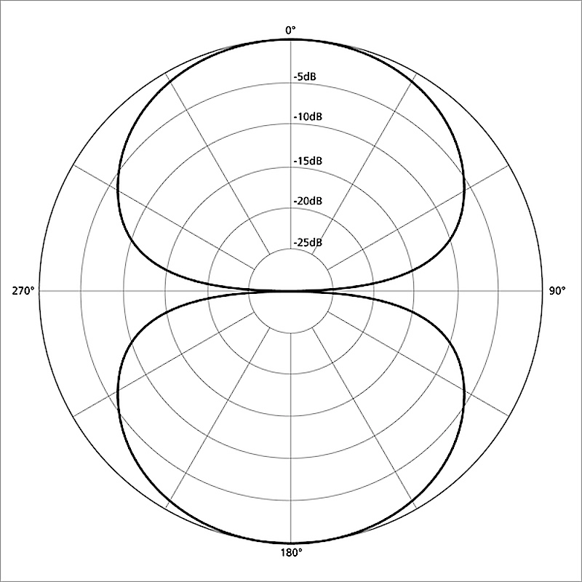
b. Bidirectional polar patterns usually pick up sound in both the front of the microphone and behind it equally. They generally reject sounds coming from the sides.

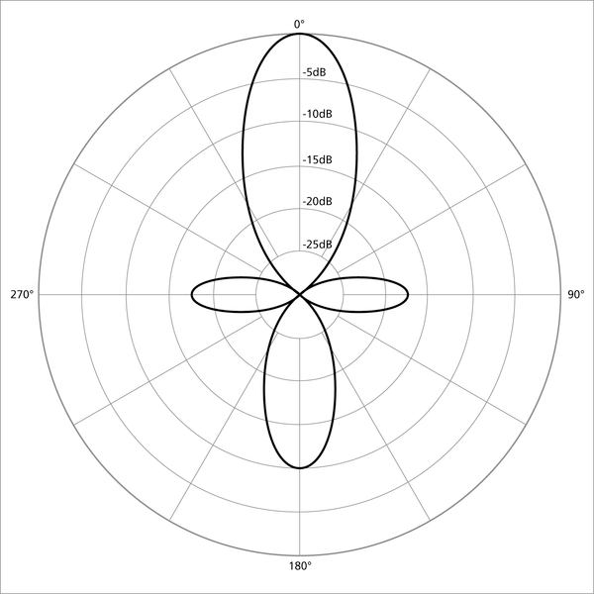
c. Shotgun mics are a special type of microphone with a bi- directional polar pattern, yet more sensitive toward a very narrow range of the front of the microphone.

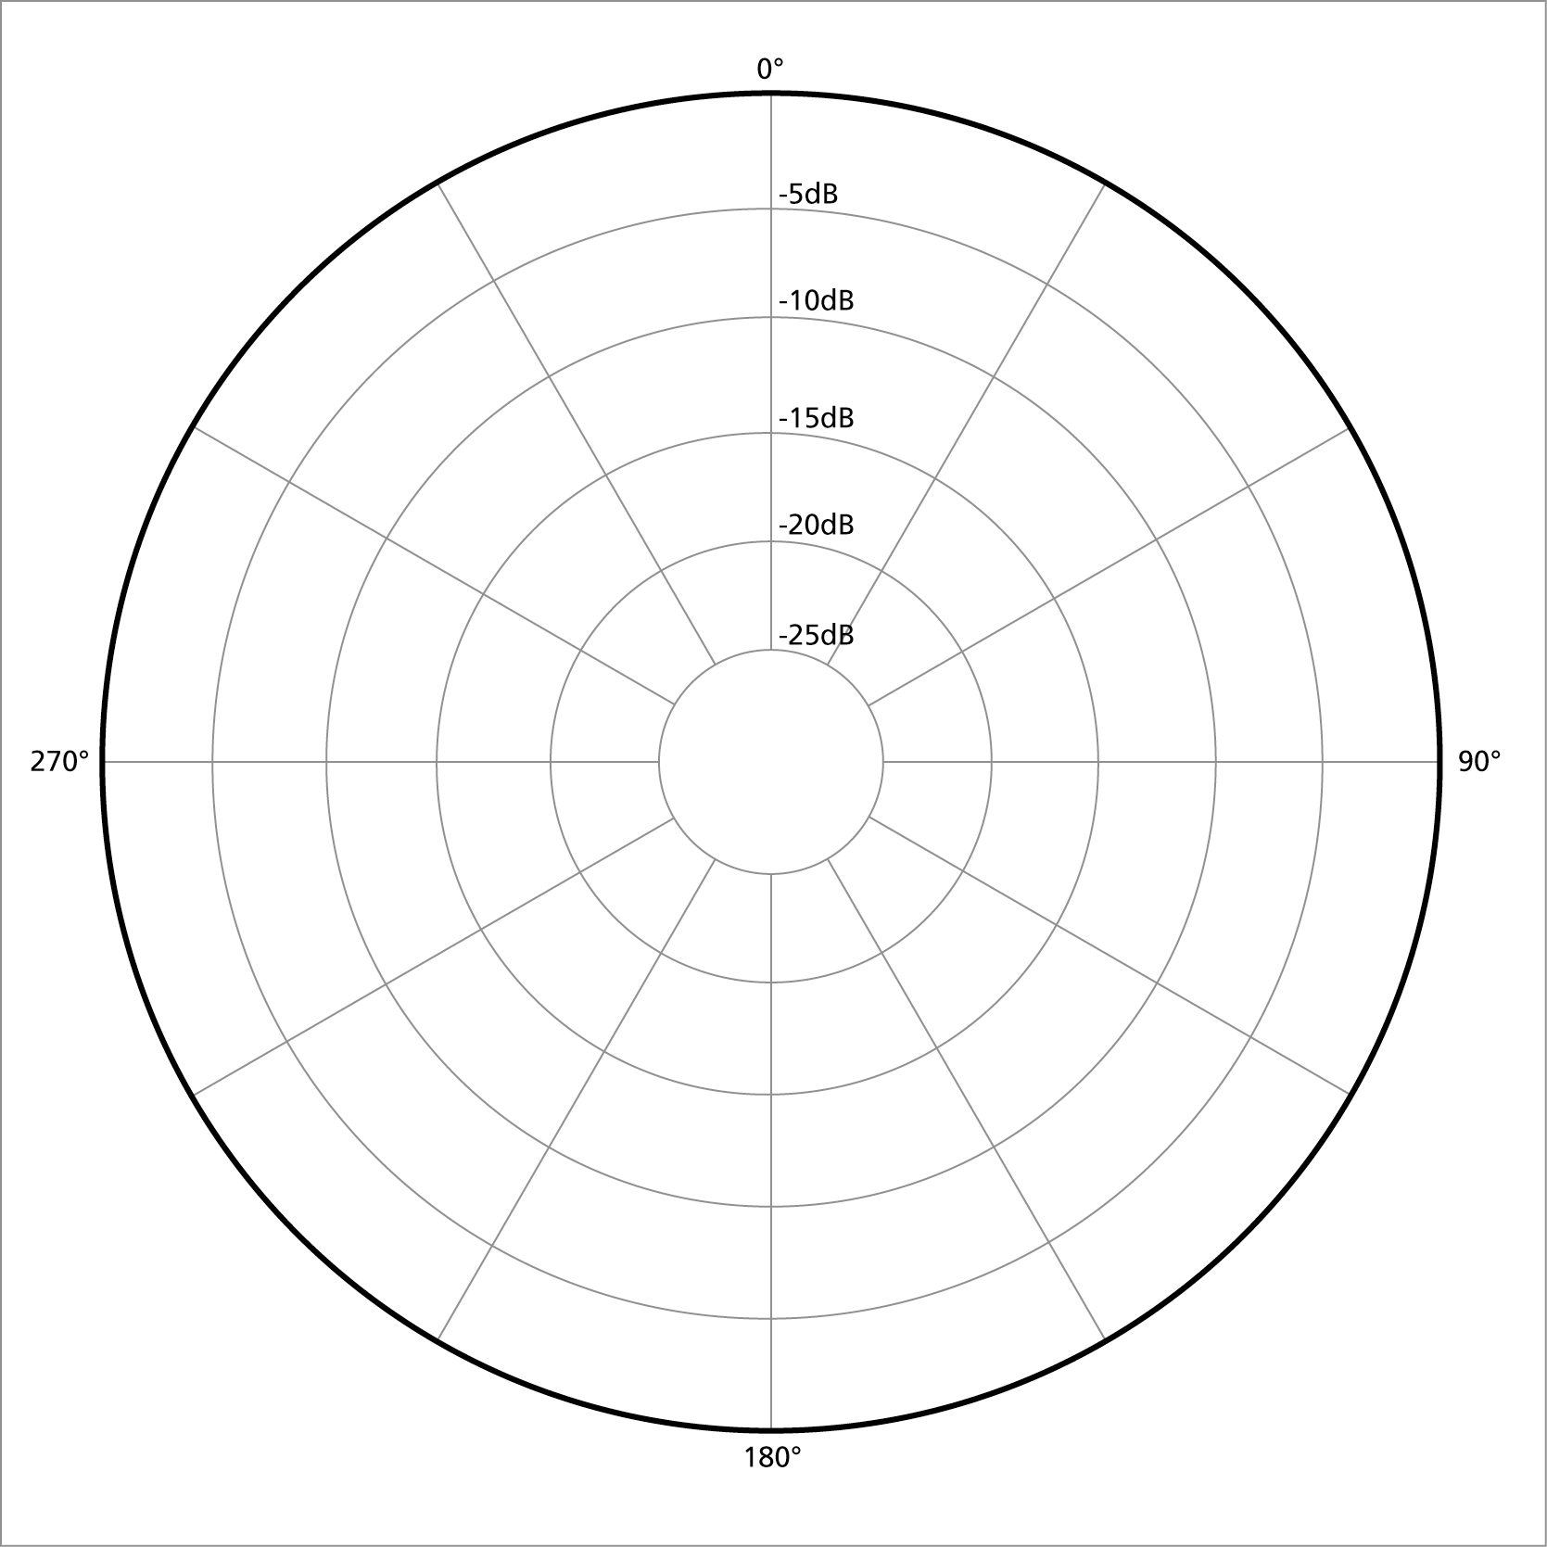
d. Omnidirectional polar patterns pick up sound in all directions equally. The polar pattern is represented as a circle, shown below. Omnidirectional mics pick up sound from all directions, so are good for picking up room reverberation and other nearby instruments or sympathetic sounds. When used in pairs, they are good for recording performances in reverberant spaces.

6. Contact microphones have no polar pattern. They are attached to a vibrating surface, like a guitar, or a metal cabinet, and respond to the physical vibration of an object. They do not pick up other sounds in the room, thus are very good for isolating an instrument. Contact mics are also called piezo mics, because they feature a piezo disc. Piezo discs are found in old electronic devices like handheld video games or smoke detectors. When given a current, they produce a sound. They also work the other way around. If you give them a sound, they will produce a current; the current necessary to produce an analog of the original source sound wave.

7. For specification information about any of the EMS microphones, visit the Microphones page of our website:
theremin.music.uiowa.edu/microphones.

Bibliography:

Bartlett, Bruce. “In-Depth: Microphone Specifications Explained.” ProSoundWeb: New & Information for the Audio Professional. http://www.prosoundweb.com/article/in-depth_microphone_specifications_explained/P2/. Accessed 7 September, 2014.

Emerson, Justin. “Piezo Contact Mic.” Makezine.com. http://makezine.com/projects/make-38-cameras-and-av/piezo- contact-mic/. Accessed 7 September, 2014.

Thompson, Daniel M. Understanding Audio: Getting the Most Out of Your Project or Professional Recording Studio. Edited by Jonathan Feist. Boston: Berklee Press, 2005.

