MUS:4250:0001 COMPOSITION: ELECTRONIC MEDIA I
Fall 2016
Pitch ’n Time Pro Graph

- The Pitch ‘n Time Pro plugin has a graph function that allows you to increase or decrease pitch at a chosen rate. This is very useful if you want to create a glissando.
- To access the graph, go to Pitch ‘n Time Pro and click on the mode button in the pitch transposition area.
  - Notice that you can click anywhere in the graph to make an edit point. An edit point above this line increases the pitch up to that particular edit point. Likewise, an edit point below this line will decrease the pitch.
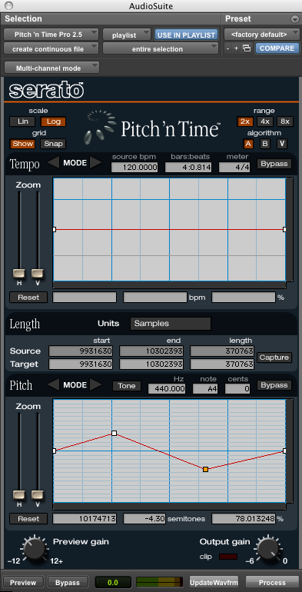
  - You can click the edit point and drag it anywhere you want within the graph.
  - You can also change the transposition range from 2x to 4x or 8x as you would without the graph. Notice how the graph changes when I click 4x or 8x.
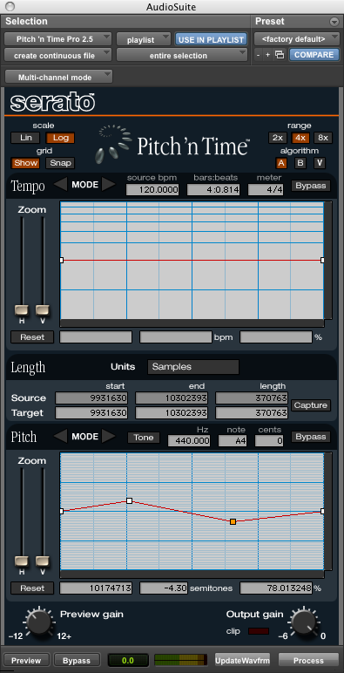

- The time shift also contains a graph just like the one for pitch. Watch what happens in the pitch shift graph when I move an edit point above or below the line.
- Be careful not to glissando too quickly or too much in one direction. The effect may be deemed comical. This is especially certain of short ascending glissandi over 2 semitones. A glissando within the range of 1-2 semitones are often more expressive than those that exceed this range.
- If you want the line to become flat again, click the reset button at the lower left corner of a graph. Notice there are individual resets for time shift and pitch shift.

