MUS:4251:0001 COMPOSITION: ELECTRONIC MEDIA II
Spring 2017
Anechoic Chamber

- This handout serves as an introduction to the anechoic chamber and includes some discussion of how these chambers are able to absorb the reflection of sound. Directions to the anechoic chamber are provided at the end of this handout.
- An anechoic chamber is a non-reflective, echo-free room. It is heavily insulated to prevent unwanted noise outside of the room from entering.
  - When a sound is produced inside the chamber, most of the sound is absorbed through walls with triangular-shaped wedges. A very small amount of the sound is reflected.
  - The human ear can usually perceive sounds above 0 dBA. In most anechoic chambers the noise levels will vary from 10 to 20 dB. One of the quietest anechoic chambers in the world has noise levels at -9.4 dB, well below the threshold of hearing. For a person walking into such a room, it would seem like the room is devoid of sound.
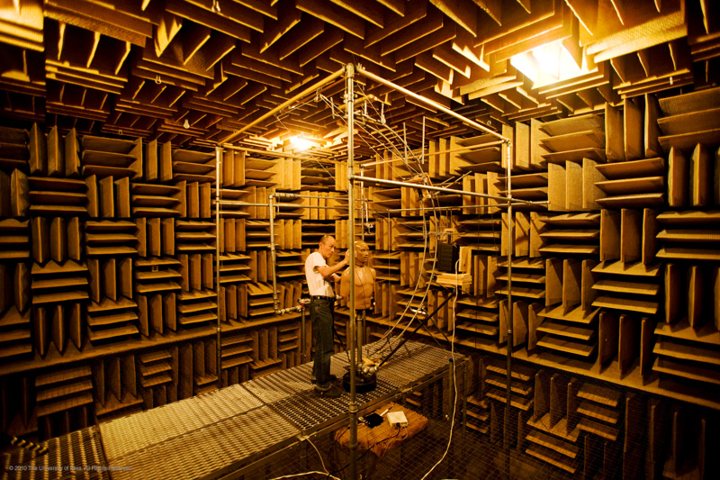
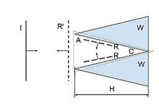
- The anechoic chamber at the University of Iowa is encased in a 30-ft cube of concrete in the basement of the Wendell Johnson Speech and Hearing Clinic. The walls have fiberglass wedges that are attached to the walls with wire screen. Each wedge is 3’10” in length. They absorb the sound when it travels toward the wall. The fiberglass wedges are found on all walls, including the floor and the ceiling. When you go inside, you’ll be walking on a metal catwalk above the floor. The anechoic chamber at this university can absorb frequencies down to 60 Hz. The reason for this limitation is because of how the fiberglass wedges are configured inside the room.

- Directions to the anechoic chamber. The anechoic chamber is located at the Wendell Johnson Speech and Hearing Center, 250 Hawkins Drive in Iowa City, IA, 52242. There is a parking garage for those with cars across the street from the Wendell Johnson Speech and Hearing Center. For those who wish to take the Cambus, the Red Bus route is free. There are Iowa City buses, such as Melrose Expresss, Plaen View, and Westside Hospital, that will take you even closer to this building, but you’ll have to pay to ride them.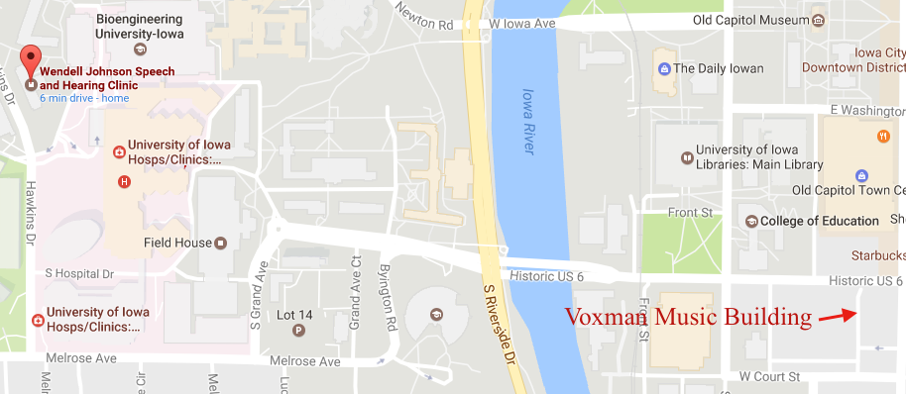
- Once you arrive at the Wendell Johnson Speech and Hearing Center, to get to the anechoic chamber, you’ll want to enter through the main entrance, turn left, go straight down the hall until you reach the stairwell. Then, go down to the bottom of the stairwell, and you’ll end up at the anechoic chamber is at the bottom of this stairway.

The measurement dBA is used here to express noise levels, the relative loudness of a sound as perceived by the human ear. 25 dBA, as an example, would be a measurement for the loudness of a person whispering in a room. The measurement dB, although it can be expressed as a measurement of sound pressure, is more generic as a means of expressing a relationship between two values for something physical, either power or intensity. dB can also be used to express voltage, radar, radio power, energy, and field strength.

